**Background**

* Constructor (called when object created, parameters)
* Default constructor (No parameters given )
* Destructor (deletes all allocated memory on heap)

**Factory Method**

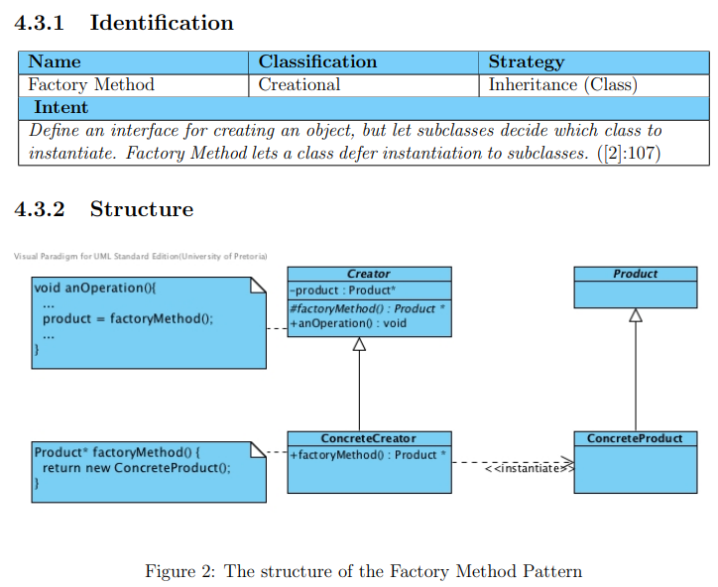

* Participants
  + Creator
  + ConcreteCreator
  + Product
  + ConcreteProduct
* Concrete creator class -> creates specific -> concrete product
  + Parallel hierarchy formed
  + Dependencies between hierarchies on concrete level
  + ConcreteCreator “uses a” ConcreteProduct”
* Pros:
  + Objects created in orderly fashion
* Using only a wrapper with a descriptive name for the construction process [3], does not mean that a Factory Method design pattern has been used
* Related pattern
  + Template Method
  + Abstract Factory
  + Prototype
  + Singleton

**Example**



